Lab # 01 OBJECT

To Study about basics of :
- Data Communication
- Types of Networks

THEORY

Data Communication:

Data communications are the exchange of data between two devices via some form of physical medium (transmission medium) such as a wire cable. The word data refers to information presented in whatever form text representation (text, number, images, audio, video etc.).

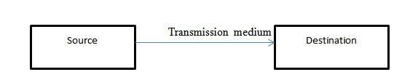

Data Communication Model:

The fundamental purpose of a data communications system is the exchange of data between two parties. This device generates the data to be transmitted; examples are telephones and personal computers.

Key Elements of the model:

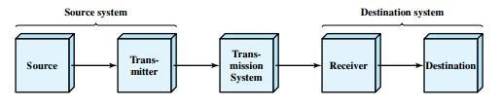

- Source. This device generates the data to be transmitted; examples are telephones and personal computers.

- Transmitter: Usually, the data generated by a source system are not transmitted directly in the form in which they were generated. Rather, a transmitter transforms and encodes the information in such a way as to produce electromagnetic signals that can be transmitted across some sort of transmission system. For example, a modem takes a digital bit stream from an attached device such as a personal computer and transforms that bit stream into an analog signal that can be handled by the telephone network. 

- Transmission system: This can be a single transmission line or a complex network connecting source and destination.

- Receiver: The receiver accepts the signal from the transmission system and converts it into a form that can be handled by the destination device. For example, a modem will accept an analog signal coming from a network or transmission line and convert it into a digital bit stream.

- Destination: Takes the incoming data from the receiver.

Example :

Communication between a workstation (A node or stand-alone PC that is connected with network is called Workstation. A workstation is generally a client) and a server over a public telephone network.
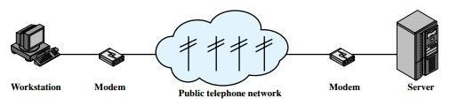

Computer Network:

A computer network is a set of computers connected together for the purpose of sharing resources.
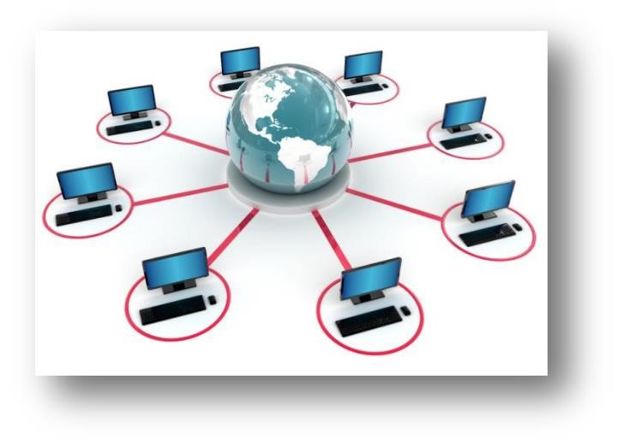

Computer Networking:

Computer networking is an engineering discipline that aims to study and analyze the communication process among various computing devices or computer systems that are linked, or networked, together to exchange information and share resources. Types of Network:
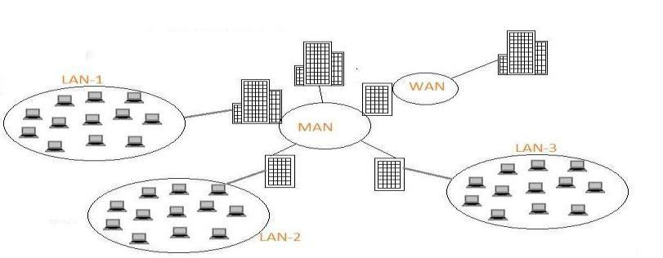

LAN

- LAN (Local Area Network) is a group of computers and other network devices   which are connected together. 
 
- All the devices that are part of LAN are within a building or multiple building.  • LAN network has very high speed. 

WAN

- WAN (Wide Area Network) is a group of computers and other network devices which are connected together which is not restricted to a geographical location.
  Internet is WAN 
- All the devices that are part of WAN have no geographical boundaries. 
- WAN speed varies based on geographical location of the servers. WAN connects several LANs 

MAN

MAN ((Metropolitan Area Network) is a larger network of computers and other network devices which are connected together usually spans several buildings or large geographical area.All the devices that are part of MAN are span across buildings or small town 

LAB TASK:

- Difference between network and networking?

__________________________________________________________________
__________________________________________________________________
__________________________________________________________________
__________________________________________________________________
__________________________________________________________________

- Components of data communication model?

__________________________________________________________________
__________________________________________________________________ __________________________________________________________________

- Does analogue conversation take place in source as transmitter?

__________________________________________________________________
__________________________________________________________________ __________________________________________________________________

( 4) Give an example of data communication model?

__________________________________________________________________
__________________________________________________________________
__________________________________________________________________ __________________________________________________________________

- What is Peer-to-Peer network?

__________________________________________________________________
__________________________________________________________________
__________________________________________________________________ __________________________________________________________________

- Build LAN & WAN environment using Packet Tracer?

